Name: Class:
Introduction
For a quantity to have an exact value, it must either be defined or obtained by counting. All measured quantities have an inherent uncertainty because all instruments used to make measurements have limitations, and the people operating the instruments have varying skills.
The accuracy of a measurement is an expression of how close the measured value is to the ‘correct’ or ‘true’ value. The precision of a set of measurements refers to how closely the individual measurements agree with one another. Thus, precision is a measure of the reproducibility or consistency of a result.
The precision of measurements is sometimes expressed as an uncertainty using a plus/minus notation to indicate the possible range of the last digit. An alternative method is to indicate the certainty of the measurement by the use of significant figures.
To clarify the number of significant figures in a measurement, the value may be written in standard form. A number written in standard form is expressed as a number greater than 1 but less than 10, multiplied by 10^{x}, where x is an integer.
When a calculation involves multiplication and division, the result should have the same number of significant figures as the factor with the least number of significant figures. For addition and subtraction calculations, the result should have the same number of decimal places as the number used with the fewest decimal places. In most calculations you will need to round off numbers to obtain the correct number of significant figures.

No. | Question | Answer
Which of the following quantities would have an inherent uncertainty?
A The number of pages in your textbook
B Your measured height (in cm)
C The number of mL in 6.0 L
D A volume of liquid measured using a pipette
Shooting targets may be used as an analogy to show the ideas of precision and accuracy in measurements. Label each of the shooting targets below as representing one of the following situations:
N for neither accuracy nor precision
B for both precision and accuracy
P for precision, but inaccuracy.
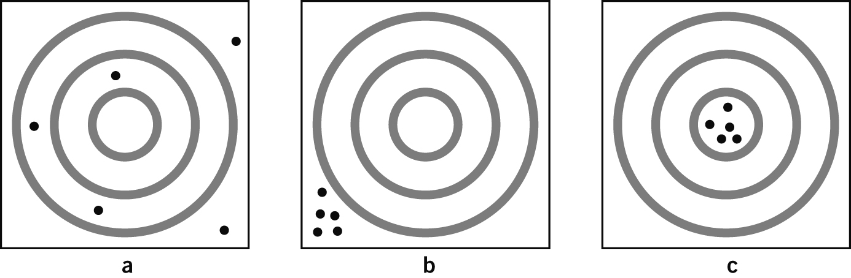
 | Why are measurements in experiments often repeated several times and the results averaged?
State the number of significant figures in each of the following measured quantities.
a A temperature reported as 26.1°C
b A burette reading of 32.34 mL
c A mass reading of 0.0471 g
d A time recorded as 6.000 s
Express each of the following numbers in standard form, ensuring you use the correct number of significant figures.
a 140.7
b 5005
c 980.0
d 0.0075
Round each of the following numbers to 3 significant figures, and express in standard form.
a 7.8001
b 600.4
c 98.345
d 0.000600
Express the number 6000 in standard form to show that it contains:
a 1 significant figure
b 4 significant figures
Calculate each of the following and express the answers to the correct number of significant figures.
a 5.6 × 120
b 0.0045 × 67.1
c 0.046 ÷ 0.023
d 63 × 7.06
Perform the following calculations and round off the answers to the correct number of significant figures.
a 3.256 + 45.2 – 3.815
b 12.13 + 342.0 + 4.108
 | A dozen eggs have a mass of 722 g. What is the average mass of the eggs?

